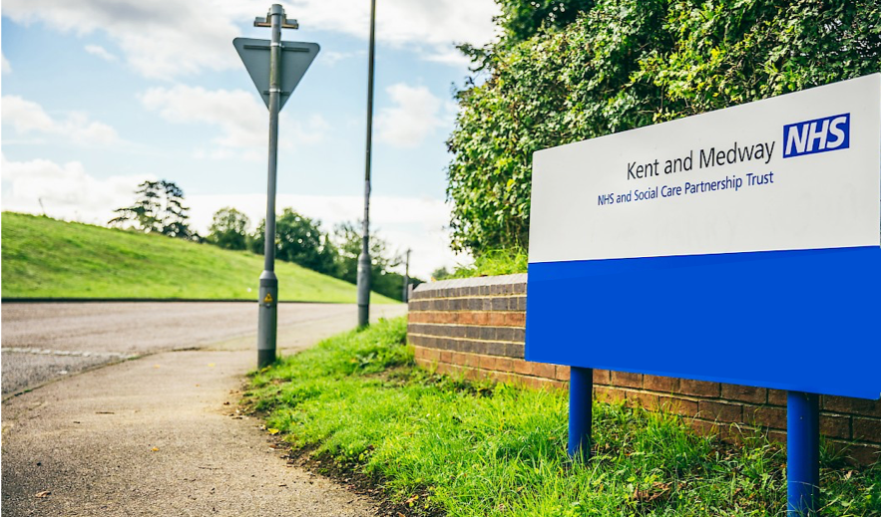
Case Study

Compliance Reporting
Kant and Medway NHS and
Social Care Partnership Trust

Case Study

Accessible + Simple + Integrated = Results

Kent and Medway NHS and Social Care Partnership Trust (KMPT) use Totara Learn to support the trust’s healthcare providers, delivering self-service rollout and CQC compliance compatibility.

About KMPT

KMPT provide mental health and social care services for Kent in partnership with Kent County Council. In Medway, they work closely with the local unitary authority to provide joined-up health and social care services.

As one of the larger mental health trusts in the country, they cover an area of 1,450 square miles and serve 1.7 million people across Kent and Medway employing 3,318 staff who are located in 66 buildings on 33 sites.

The Challenge

As an organisation that delivers secondary healthcare services to the public, KMPT is inspected regularly by the Care Quality Commission (CQC). Inspections can be planned or unannounced, requiring that the Trust has real time access to compliance reports at all times. This system means that staff and their managers have real time data at their fingertips, and that staff are able to use their learning management system easily to keep themselves updated with their statutory, mandatory and essential training.

Patient care is their priority, they are employed to look after patients, provide support to families and loved ones and are under pressure to meet not only internal, but national targets. Undertaking training that relates to their role, and to meet local compliance requirements, is essential however it is important for the trust to have an easily accessible system which is simple to understand and intuitive to use.

It is imperative for KMPT that user engagement was given a high priority on their Totara Learn deployment. This engagement was essential for making ensuring staff were able to use the system effectively and without any interruptions to compliance.

The Solution

Totara Learn, and the customised plugins provided by Chambury Learning, enable the end user to have all the information they need at their fingertips with individualised pages and nothing more than one or two clicks from their homepage. Managers and supervisors can see compliance figures at the entry point (logon) and can instantly take any necessary action with minimal system knowledge and time. Users see their own compliance; managers see both their own and their direct / indirect staff data, driving up the compliance of the whole organisation.

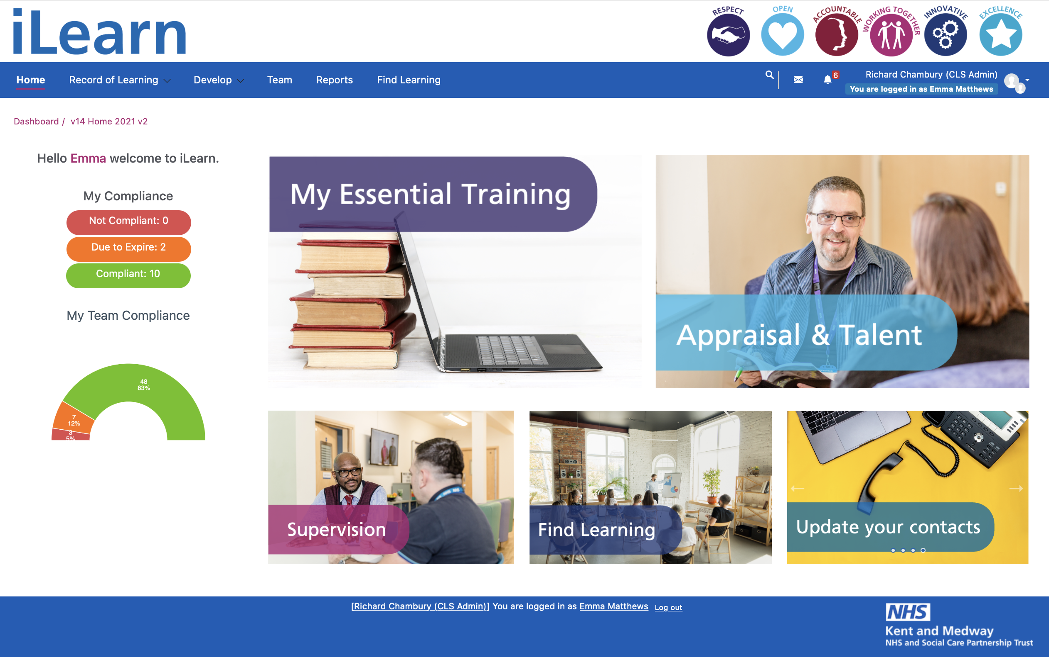
Feedback has been positive. All users feel at ease with the system, have the ability to view their compliance, and can update their learning seamlessly. Statistically we can see that compliance is up and user engagement statistics are positive.
Accessible and digestible.

This includes not only the core functions of the system, but graphical indicators to inform staff and managers of compliance and areas where they can record personal learning, view full learning history, but not over-whelm end users with information on scheduled learning requirements for the future.

Totara Learn allows fully customisable messages, and Chambury Learning supplement this with custom plugins that manage anniversary reminders for Appraisal and other non-training functions. This has already proved to be effective across the Trust.

KMPT have deployed Chambury’s bespoke series of Dynamic Info-Blocks that allow site administrators to create graphical intelligent dashboards that are individualised to each user that logs-in and is of course visually stimulating. Blocks can display data in donuts, single cubes, traffic lights, to name a few. All customised to the trust brand.

Dashboards are an intuitive way of providing the most important set of information on the LMS interface in plain language. This can range from renewal, one-off and appraisal compliance shown either by graphical illustrations or contextual data. All fully interactive, with links to view more detailed reports.

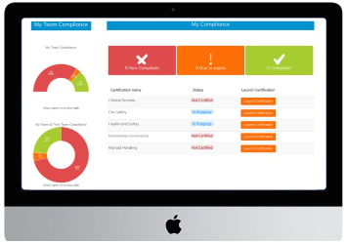
If you are a manager at KMPT you will see your team compliance; if you are a nurse you will see links to your Revalidation Toolkit; if you are a staff member, you will see your personal compliance with direct links to what you need to do today to get compliant. Getting the homepage ‘right’ for KMPT was important to ensure they engaged with the system. Working in conjunction with Chambury’s site designers the LMS fully reflects trust branding, provides full accessibility to different users, and displays Chambury’s Dynamic Info-Blocks.

Reporting is key to KMPTs Board. Their ESR hierarchies were uploaded to Totara as part of deployment, and updated automatically through Active Directory, with Chambury’s Dynamic Info-Blocks allowing them to drill into their hierarchy with percentage reporting through levels right down to the actual staff and their compliance in RAG rated [red-amber-green] formats. Real time live pivots in Totara makes KMPTs admin teams workload lighter.
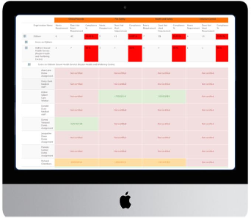
It’s a small detail, but the KMPT colour palette was applied to each Info-Block so that the RAG rating matches the brand, and that colours match local percentage boundaries meaning that they can set RED up to 50%, AMBER up to 75% [and so on].

In conjunction with personal RAG blocks and colour coded launch blocks this means that all users know what to do and when. Helping t keeping the trust compliant.

Funding

Like all NHS organisations, KMPT has to budget carefully with funding predominantly catering for service provision. Whilst the LMS supports this, training should be efficient and meet budgetary requirements.

Being open source, Totara Learn is a cost-effective solution for the trust and after a thorough procurement exercise they selected Chambury Learning, a Platinum partner located in the UK to partner with.

Working with Chambury also enabled KMPT to access a huge resource of freely available national content eLearning, at no additional cost, that learners can access 24/7/365 in a seamless process with full reporting. They are also experimenting with web conferencing using Totara and other open source tools that incur no additional cost.

The Results

KMPT went live with Totara Learn in September 2018. Within three months they are enjoying over 81.3 per cent user engagement, and an average of 88.64 per cent compliance for all core training. Pretty remarkable.

On boarding; A new member of the team sees their on-boarding induction dashboard to introduce them to the organisation and their required program of learning that they are required to completed as a ‘new starter’. Once they have completed these programs they will be placed into their appropriate audience and thus presented with their customised dashboard.

External Staff; Users that are external to the organisation such as trainee doctors and nurses can login and gain access to local courses via dedicated dashboards. This opens up learning within the LMS to an external audience, bringing face-to-face training, seminars, conferences and online learning to your students, volunteers and locum staff.

Non Clinical Staff; staff can view dashboards that show fully interactive blocks illustrating their personal compliance across mandatory training – with ePortfolio and appraisal information within one click from their homepage.

Clinical and Medical Staff; qualified clinical and medical staff can view dashboards that show their personal compliance across targeted core training – with additional CPD, ePortfolio, Revalidation, appraisal, supervision and study leave information all within one click from this main dashboard.

Managers; Managers login and immediately see their compliance but with the addition of viewing their fully interactive direct and indirect staff graphical data informing them of their team and wider team compliance without any further clicks. Instantly giving them the necessary tools to improve compliance of their own staff. When managers see RED, they act. When managers see GREEN, they can relax.

Senior Manager and Board members; Reports at their fingertips with full export functions. In pivot tables for immediate use without any Excel knowledge.

Administrators; System administrators have their own dashboard which include direct links within the system to the areas that often utilise.

They don’t need to fully reply on Chambury for this, its all designed so their administrators can manage dashboards locally and so any blocks can all be mixed and matched, to form a series of targeted interactive dashboards to meet their ongoing organisational and their staff’s professional requirements.

Since the introduction of iLearn 76 per cent of our staff have accessed the system in just 12 weeks, this hasalreadyledtoimprovedcompliancewithe-learningbasedEssentialTraining. Asstafflogintheyare taken straight to their dashboard where they immediately see what essential training they are in date with, due to expire and what training is out of date. This system is bringing about a culture of change, making employees responsible for their own learning and allowing them to manage it effectively. The easiness of booking classroom-based sessions and completing e-learning sessions has revolutionised how training is accessed throughout the trust.

Managers are able to access reports in real time and are immediately able to see where they need to focus their attention, as well as being able to see which staff are on what training to allow them to better plan their rotas.

From a learning management point of view, iLearn has given us the ability to better manage compliance, to better plan what training we offer and where. It has allowed us to access the wide range of National NHS e-learning content that we had previously been unable to use.

Head of Learning and Development Kent & Medway NHS & Social Care Partnership Trust

About Chambury Learning

Chambury Learning works with organisations that are looking at how technology can assist them to develop their learning, organisational development and staff performance systems.

They work with you to ensure that the system fits the local need. Their extensive experience spans public and private businesses with a specific focus on Healthcare.

Chambury Learning prides itself on high levels of customer service providing an individual service tailored to each client’s needs, all at a cost effective price to meet your local budget.
